110+ Languages Are At Your Fingertips: Transparent Language Online Now Available FREE at [Library Name]
Planning a trip to Italy to celebrate your anniversary? Collaborating with your Chinese counterparts in your company’s Beijing branch? Just want to brush up that language you studied for four years in school, but somehow can’t seem to remember at all? We’ve got you covered.
We are excited to announce that we now offer Transparent Language Online free to all library card holders. Whether you’re starting at the very beginning with a new alphabet or you’re an intermediate learner looking to enhance your vocabulary and grammar knowledge, Transparent Language Online can help. Available for learning 110+ languages, plus English (ESL) materials for native speakers of 30+ languages, the program has something for everyone:
- Alphabet Courses: Full-length alphabet courses are available for 18+ languages to familiarize you with new writing systems, empowering you to learn one (or more!) of those “intimidating” languages like Mandarin Chinese, Hindi, or Arabic.

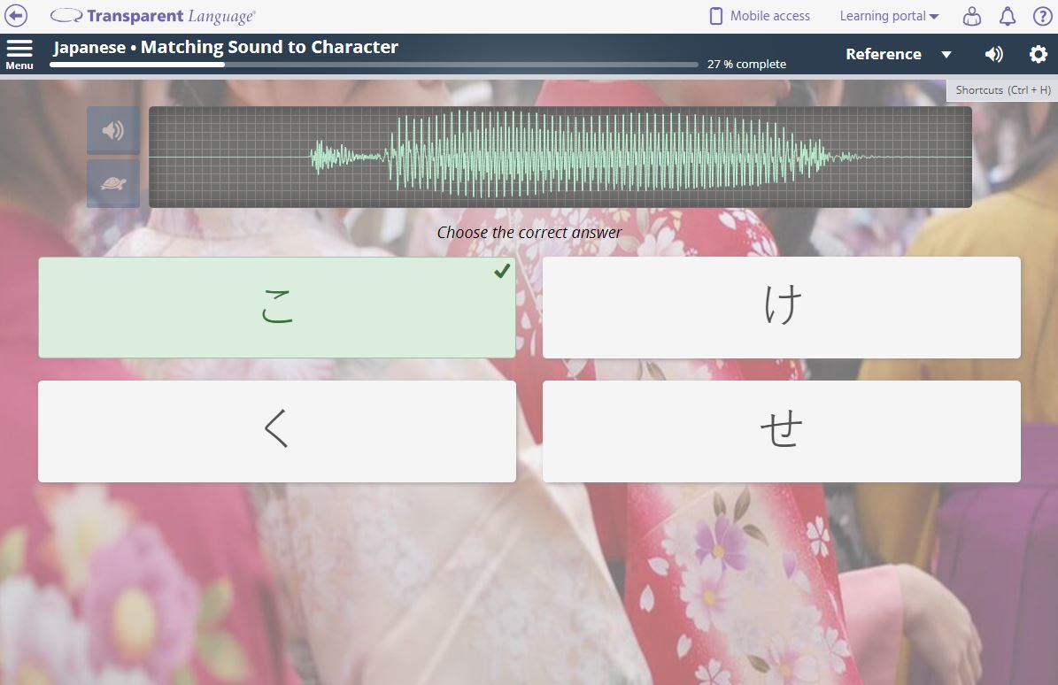

- Essentials Courses: These courses guide you through 30+ lessons of pure language fundamentals, including meeting and greeting, expressing wants and needs, planning for a trip, dealing with money, asking for help, and beyond.
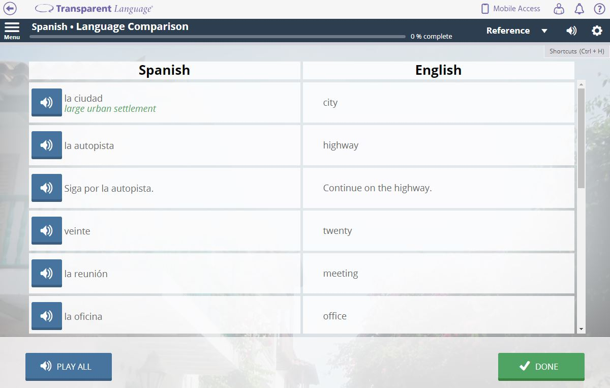

- General Vocabulary: Hundreds of topically-organized vocabulary lists will teach you thousands of new words and phrases through a completely redesigned suite of fun, interactive activities that build all four core language skills: listening, speaking, reading, and writing. No more drilling paper flashcards!

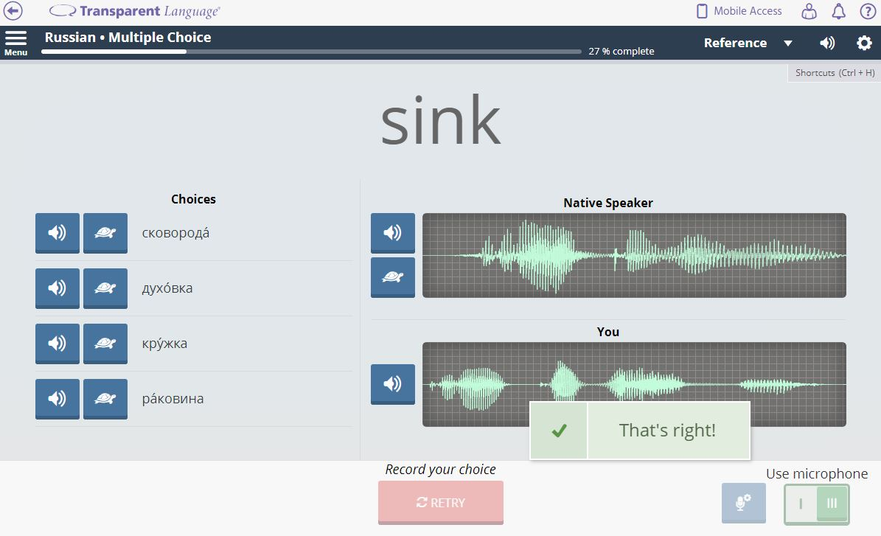

- Grammar Reference: An extensive index of grammar materials rounds out the learning experience, providing both written and multimedia explanations of grammar rules and patterns.
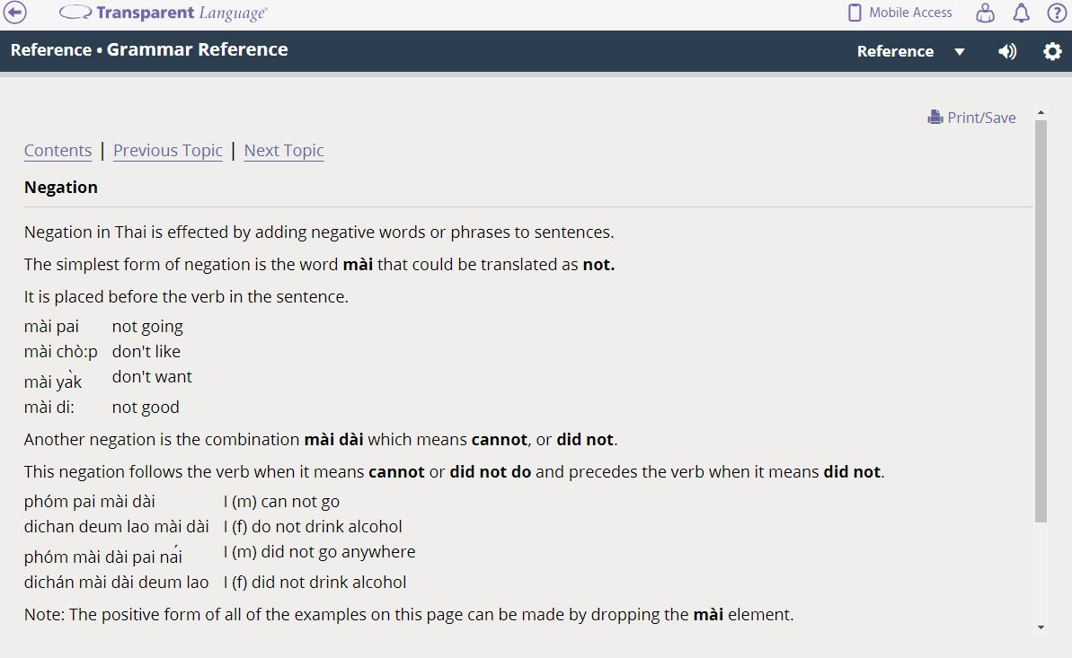
Worried that you won’t be able to learn on your own? A customizable Learning Path allows you to choose what you want to learn, while an integrated analytics system tracks your progress, periodically prompting you to review material that you haven’t seen in a while. It’s like having a built-in teacher there to keep you on track toward your language-learning goals.
Best of all, Transparent Language Online works on any Internet-connected device, so you can learn from your laptop, phone, or tablet.
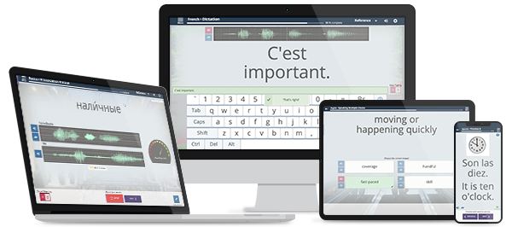
To learn more about Transparent Language Online and preview the program, swing by the library for a demo and to set up a free account. You can also access the program directly at [library website].
Feel free to contact us with any questions at [preferred library contact info].

